CENWP-OD-B 28 September 2023

MEMORANDUM FOR THE RECORD

SUBJECT: 23BON095 MFR AFF Valve 15 Salmonid Mortality

On the afternoon of 28 September, Columbia River Inter-Tribal Fish Commission (CRITFC) Biologists notified Bonneville Project Biologists of one salmonid mortality found on the Valve 15 trash rack in the Adult Fish Facility (AFF). The fish was scanned for PIT tags, inspected, and returned to the river.

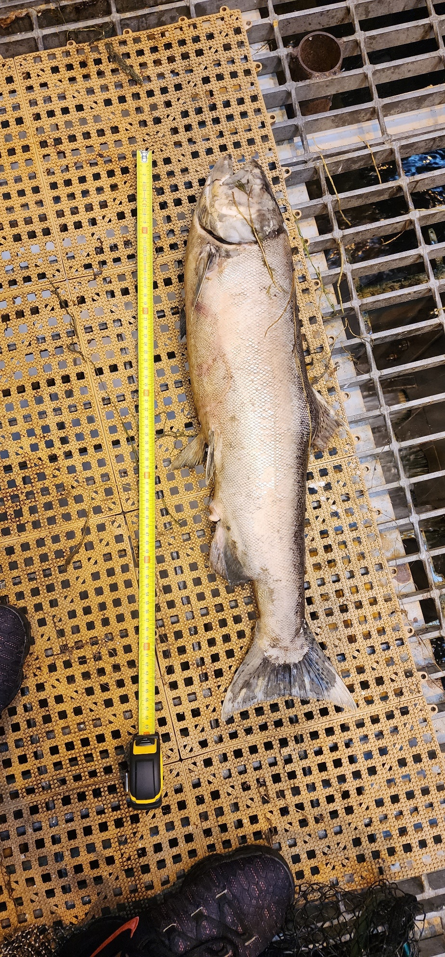
- Species – Salmonid (Oncorhynchus tshawytscha)
- Origin – Unknown
- Length – 69 cm
- Marks and tags – Adipose clip
- Marks and Injuries found on carcass – advanced decomposition
- Cause and Time of Death – Unknown
- Future and Preventative Measures – None

Sincerely,
Bonneville Project Fisheries

